THE GOLD SHARE BOTTOM--COMING INTO FULL VIEW. BE PREPARED TO TAKE ACTION!

A SEVERE WINTER STORM WARNING IS STILL IN EFFECT--FOR THE STOCKS. Before I get into gold, I want revisit my views on the stock market. Since late October I have felt we have been witnessing an extraordinary event. The market has moved up in a massive rising wedge, interrupted only by a 4% drop in November, and one that now dwarfs the previous pattern in March-April 2010. As it has climbed higher and higher, like the story of the mythical Greek sirens, it has drawn in almost every living soul and probably even some who have stopped breathing.

There is something about a market that refuses to come off that convinces even the most inveterate bear to quit resisting and get on board. Just go back to the year 2007. The Dow from its bottom in 2002 at 7,500 had shot up almost non-stop to over 14,000, a new Dow high. Who would have guessed at that time that the market would descend into the greatest economic crisis since the Great Depression? Can you remember the optimism, the talk about retiring at 40, the second home in Vail, the third one in Maui? Did a trumpet sound or an alarm sound that it would be all downhill from there? Who knew?

Which bring up today’s situation. The problem with a wedge, as we saw back in May, is that it tends to reverse unexpectedly and abruptly. Right now the potential for this one is far greater than last year, for not only has it gone on for almost twice the time, but because the sentiment readings have been as excessive as any time during the past decade. And now, something new is unfolding, another ominous technical signal for the markets-- a major bottom is rapidly approaching in the precious metals and in the mining shares. It is the goal of this report to support this view.

SOME STOCK MARKET CHARTS—THE DOW INDUSTRIALS, DOW TRANSPORTS, AND THE NASDAQ. HAS THE WEDGE BEEN BROKEN?

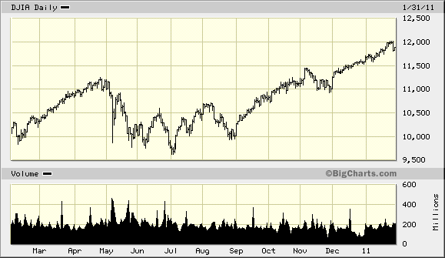

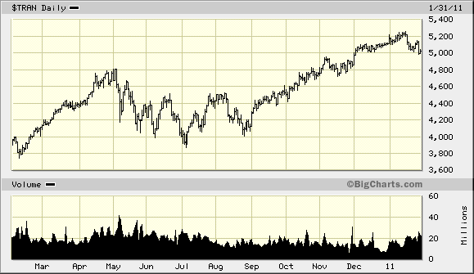

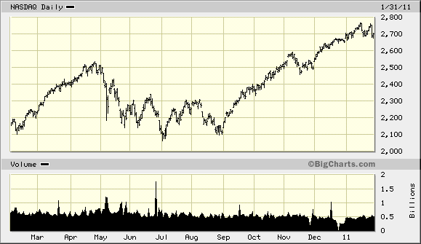

MAKING AN ULTRA-BULLISH TECHNICAL CASE FOR GOLD Although we might be witnesses of a riveting stock market drama, because of the uniqueness of the gold and silver situation, I believe our attention must now be shifted to the precious metals shares.

Most gold analysis, as it should, tends to focus on the metal's fundamental merits: Supply and demand for the metal, fiat money creation (QE2,) a fractured financial structure, the inevitability of monetization due to the unsolvable debt problems and the like. Most of the articulate gold champions like Bill Murphy, Jim Sinclair, John Embry and John Hathaway consistently and eloquently explain gold's fundamentals. These men are all required reading, if you are an investor.

But my interest and bent tends to be towards the technical side. This might include sentiment indicators, the Commitment of Traders numbers, the behavior of the listed shares, and just an ear to the ground to see how the media treats the precious metals' world. The fundamentals set the foundation for our long-term confidence: the technical indicators try to pinpoint the timing. Phew! Now that is out of the way, I can get to what I really wish to say, and for once it is extremely positive. And for me this is a wonderful change.

A SELLING CLIMAX COMING IN GOLD?
As you see below, the gold price has been making a rolling top although this is an arbitrary view since the beginning of September (it is not a coincidence that the stock market bottomed out just before then, as everything has been feeding off a massive surge of liquidity.) Right now gold has the appearance of a scary looking spike down. Since November I have been favoring a drop under $1,300 because (1) $1,300 has never been tested and (2) As gold bottoms do, it would serve to shake out a lot of the nouveau bulls and (3) It would draw in a lot of new shorts, thus preparing for an explosive catapult up out of the bottom.

I believe we are getting closer and closer to an cemented bottom also in the shares, although the events in the Middle East has sewn some doubt how much lower we can realistically go. It would be fitting that we would go through 500 on the HUI once again since it has been a formidable point during the ride up.

But the critical point is that we are almost there (if we aren't already.) So rather than be rattled by a failing stock market which will conjure up frightening memories of 2008, or speculating about gold going down to $1,100, it is time instead to take a POSITIVE and well planned strategy, and prepare to take action.

I feel we are almost at, what I call an historic inflection point in the world markets, and if I am correct, monumental monetary events are lurking just ahead. More importantly, it will mark the true beginning of the once-in-history gold share market in which some miners will go up 100 times, or even more. Sound absurd? I have been called worse. Remember the gold market has been moving parabolically, just as the Nasdaq did in the 1990s, but with a difference. The Nasdaq was an unsustainable bubble. Gold is real money, in an insane monetary world.

I am not at all sure how this will play out. By this I mean will there be a banking crisis, might the markets be shut down, will there be a squeeze on gold, might there be uncontrollable political or geopolitical events or might the monetary authorities summarily monetize debt? One or more of these is possible, if not right away, then some time not far down the road, But, at this time, I would be fully prepared for an unprecedented opportunity.

REVIEWING THE REASONS FOR MY RECENT CAUTION ON GOLD. During the several months of calling for caution towards the gold shares, I gave several reasons. Let's look at them so we can then compare it to today's situation.

A. A HIGH SENTIMENT TOWARDS GOLD. Until recently the various sentiment polls displayed a high degree of confidence. The Hulbert, Market Vane, and Sentiment Trader polls all were at levels where a correction was probable. And it came.

B. THE BEHAVIOR OF THE LISTED GOLD SHARES IN THE HUI—MY PRIMARY REASON FOR BEING CAUTIOUS
Even though gold had risen continually since September, the components of the HUI index failed to confirm the rise. In fact, most of them had retreated back to their prices when gold was around $1250 (see the charts toward the bottom of this article.) As a point of reference, I have alluded to the stock market breakout in August 1982 as the probable pattern the HUI should eventually take. The stock market, after 16 years of going nowhere, finally burst upward 40% in just two months, and eventually almost 400% within 5 years. (See the charts immediately belo.) Even though we have had a ten year run in gold, we had not had such a run over the 10 years of this gold cycle. The HUI components were still languishing, and more disconcerting, the shares would often gap up go nowhere, and then turn down. This was not the way a bull market that had broken out should have behaved.

OVER TEN YEARS GOLD HAD RISEN FROM $250 TO $1400, AND YET STILL HAD NO TRUE BREAKOUT. TODAY, THE HUI IS ONLY 25% ABOVE ITS PRICE OF 2006 WHEN GOLD WAS $700. LOOK FOR A BREAK OUT SIMILAR TO THE DOW'S TO COME SOON.

C. THE EXTREMELY HEAVY VOLUME IN THE SILVER SHARES
As silver shot up in the summer, the silver mining shares started to rise sharply also. While this occurred, the gold shares mysteriously continued to trade quietly and remain fairly static. The volume in the silver shares especially Silver Wheaton and Hecla was totally out of character with their normal trading patterns especially considering the how mute the volume in the HUI shares remained. Extraordinarily high volume usually is a clue that the stock or stock group will eventually retrace much of their moves. This doesn’t mean that the silver shares won’t be huge winners (I believe they will) but the difference in character between them and the HUI gold shares made the move very suspicious, and kept me very cautious.

BUT THE TECHNICAL READINGS BEGAN TO CHANGE.
As gold made its recent top last month, the sentiment towards gold started to drop fairly sharply, a very positive sign. This shift can be seen in various indicators.

A. THE DOUBLE LONG-DOUBLE SHORT ETFS (DGP-DZZ)
Until about 4 months ago, the volume ratio between the double long gold etf (DGP) would customarily trade about double the volume of the double short (DZZ). This ratio would be logical since gold has been up over the last decade and the bias should be expected to be higher on the long side. But strangely the ratio suddenly shifted sharply and strangely to the double short ETF. In fact, over the past month or so, it has been almost 3:1, DZZ to DGP. I didn’t have or read of any explanation to explain this shift, but I assume it meant that the traders had turned very bearish for whatever their reasons, but because of my contrarian views, the very size of the switch should be very bullish.

B. THE CENTRAL FUND OF CANADA--PREMIUM AND DISCOUNT.
Very recently one of the funds actually sold at a discount to its net asset value, very unusual doings. Although historically this has not always the best coincident figure, since it happened with all of the others sentiment indicators becoming more bullish, I believe it is significant and positive.

C. THE MCCLELLAN CYCLE. I have not been familiar with the McClellan cycle but I read of it last week in the Richard Russell letter. Here is what the R man pointed out. "I've been reading the McClellan Market report for years. It's one of the better and more intelligent reports that I read. McClellan does a good deal of research on cycles, and I must say some of their cycle studies work out quite well.

McClellan has discovered that there's a cycle low appears for gold roughly every 12.5 months. The cycle lows have run as follows: Jan 6, '06, Jan 8, '07, Jan 7, '08, Jan 5, '09, Jan. 4, '10, Dec. 31, '10. McClellan puts the next cycle bottom for gold at February 8, 2011. Which means that the cycle low for gold should arrive at any time between now and February 8, give or take a few weeks before or after that date. Interestingly, the McClellan cycle bottom for gold is due to arrive amid a good deal of professional bearishness regarding gold ("gold overdue for a major correction"). Thus, many traders have traded out of their gold positions, just as we near the date for the McClellan cycle bottom."

D. A CONSISTENT, POSITIVE SHIFT IN THE COMMITMENT OF TRADERS
At the recent top, as the always astute Bob Hoye’s work pointed out, the shorts held by the usually correct commercials were high enough to expect a correction. Over the past 6 weeks, the commercials have significantly reduced their positions which is part of Bob’s strong bullish call here.

E. OPEN INTEREST ON THE COMEX. I got this from Bill Murphy's column the other day. It fits the whole profile of the gold bottoming process although we now know this drop was due to one trader who had to liquidate his long position, but it still counts as meaningful.” If the goal of The Gold Cartel was to flush out the gold and silver spec longs so they could cover short positions before the mega moves higher coming this year, it has worked. The following open interest numbers for yesterday are stunning to put it mildly. Never seen anything like it. The gold open interest fell 81,752 contracts to 498,998. The orchestrated cabal takedown has sent a hoard of longs to the sidelines. The silver open interest drop, down 5368 contracts to 128,228 was very large, but nothing like what happened in the gold pit.”

F. THE PRECHTER PHENOMENON--Back in July, Dow 9,600, at the height of the disaster scenario featuring the Hindenburg Omen and the infamous Death Cross, the New York Times once again displayed its infallible contrary timing by interviewing some bears, but featuring the ever-unrepentant Bob Prechter about the imminent market collapse. Of course, we know that the market didn't comply with his smugness and instead has gone up 22%.

As we know, Bob has been the most persistent gold bears on the planet, and probably others, not only missing out on the entire gold move, but often being caught short. There is something bizarre about Bob that he can't admit that he has been so wrong, but to this day, he remains confident as ever that gold will eventually plummet. But here is why I mention him. After months of silence I received two typical smug teasers about gold’s weakness, as though he will eventually be vindicated on his decade long wrong way Corrigan call. Will history repeat as it did back in July? I think the odds are very good.

G. THE VARIOUS SENTIMENT POLLS

1. THE SENTIMENT TRADER GOLD POLL Chart courtesy of Sentiment Trader. As you can see, the sentiment has now dropped back to the point when gold moved from under $1200, and even back to the May 2009 low when was just under $1100.

2. THE MARKETVANE POLL MarketVane’s Bullish Consensus for gold dropped down to 62%. This matches last’s July low when gold was under $1200.

3. THE HULBERT SURVEY During the past month the Hulbert figures have dropped from over 50 down to 1. This means that the typical gold letter writer is advising his readers to be almost totally out of the market. The last time this indicator was negative was July 13th 2009, when gold closed at $922.50. The Hulbert Poll is one of the most useful gold sentiment indicators.

4. THE RYDEX PRECIOUS METALS CASH FLOW Chart courtesy of Sentiment Trader Notice that whenever there has been a sharp reduction in the PM assets, such as the bottom in late 2008 at $730, again in May 2009 at $900, January 2010 at $1050 and finally in July at just under $1200, it marked a bottom in gold. Regardez! The Rydex holders have liquidated once more down to those levels. All of these sentiment polls or figures have one thing in common: they have returned back to bullish levels. Isn’t it amazing that this is just the opposite of the stock market?

WHAT ABOUT THE SAVVY CANADIANS? I just came across this article. "The Q1 Survey asked Canadian investment advisors to give their outlook on 16 distinct asset classes. Advisors responded whether they were bullish, bearish or neutral on the anticipated returns for these asset classes in the next quarter. Advisors' outlook for broad-based equity indices remained clearly bullish as most major stock indices delivered strong returns in 2010.

Advisors' bullish sentiment for the S&P/TSX 60™ Index remained relatively level at 62% A vast majority of advisors were also bullish on the outlook for U.S. large-cap stocks, represented by the S&P 500® Index (63%), and emerging market stocks, represented by the MSCI Emerging Markets Index (67%)."And gold? "The lone equity sector that was the exception to this trend was the S&P/TSX Global Gold Index™, which saw a stark reversal of sentiment. Bullish sentiment dropped from 64% in the Q4 survey to 33% in the Q1 Survey, despite the fact that gold stocks delivered returns of more than 25% on the year. Similarly, bullish sentiment on gold bullion dropped from 66% in the Q4 survey to 35% in the Q1 Survey." Do you get it? Gold at a new all-time high is too scary, but the stock market which is still 20% below its all-time high is still enticing.

6. THE HUI SHARES—ANOTHER KEY TO PINPOINTING THE BOTTOM
I have emphasized the lack of confirmation by the HUI shares as gold moved up from $1200 to over $1400 (really from about 2006 on.) If gold was truly ready to march up to the heights I anticipate, these shares should be 50% higher repeating the pattern of the Dow back in 1982. But as you can see, most of them ran into the proverbial brick wall in early December, a definite caution flag that gold was more likely going to correct one more time, and therefore a time to be patiently cautious. Likewise, we are finally undergoing the correction in silver.

But the important thing is that the shares are now digging in their heels, especially on those days when gold has been down sharply. The significant pick up in volume on the downside since the beginning of January in the shares is a sign to me that we are close to reaching the bottom.

I am looking for one last shot down in the metal, but as this occurs the volume in the shares should trade abnormally high and not giving any ground, and perhaps even moving up.

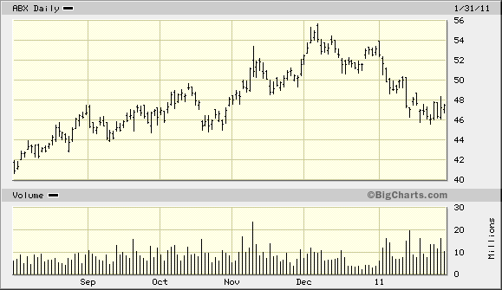

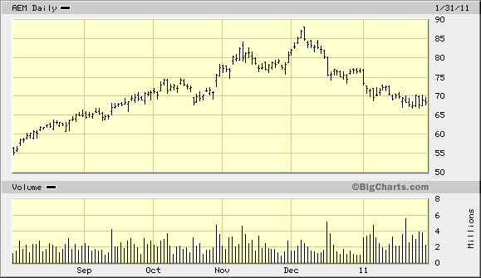

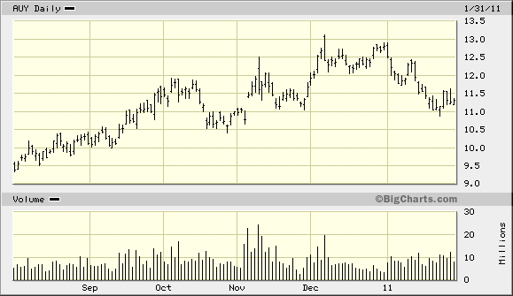

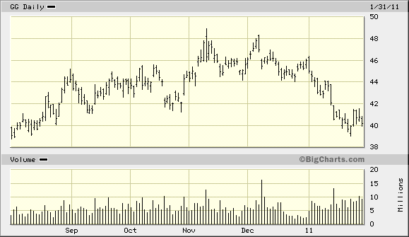

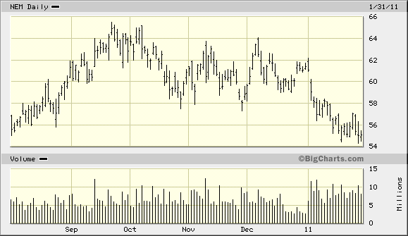

A SECOND MASSIVE SHIFT OF WEALTH
Unbeknownst to most of the mainstream media, and accordingly most Americans, the world has been undergoing seismic wealth transfers. Since 2001 the obvious one has been the shift of wealth from the western nations including America, to the eastern countries, in particular India and China. The reasons are many but fundamental—the west’s economic maturity, its profligate living style, its lack of savings, enormous debt loads, public and government loads and an aging population have all contributed to a static standard of living. The Asian nations, for almost the opposite reasons, have emerged as the growth countries of the world.

But there has also been a more subtle wealth transfer occurring. It is to those who I call “the gold community or gold believers, to use an evangelical term.” There are many people today who are just scrapping by, but who believe that precious metals are their only life preserver against an out-of-control and manipulated monetary system. It will be these investors who will find themselves not only prepared but to prosper as the eventual “pay day” arrives.

It isn't a coincidence that most of the newly wealthy countries are gold friendly, while Europe, and especially the US still view gold as an anachronism, a throwback to William Jennings Bryant. If my assumptions (plus countless others) are sound, this trend from paper to gold is about to accelerate almost at the speed of light. Being a bible lover, I find today’s world situation very similar to the story of Joseph in the Book of Genesis, as he foresaw the time of plenty turning into famine.

GET READY FOR ACTION. I have learned from experience (and pain) that the best market advice is to be positioned in advance for the major moves. I am not a fan of top calling in this monumental precious metals bull market because most likely if one sells out, he will likely find himself unable to get back in profitably.

So my advice at this point is not to try to fine tune too closely this final part of the decline even if it gets really emotional, but instead get ready to take action. This means you should be prepared for a final shot down under $1,300 that might make you think that gold may never go up again. If this happens (or it may not happen) it might take place so quickly that you might end up chasing the stocks or the metal as they rise. Jim Sinclair (I think it was him. Maybe it was Jon Nadler. It wasn’t me) has said that if you can get within 20% of a bottom or a top in a major bull market you will be doing well. So it would be wise to heed his wisdom here.

ASSUMPTIONS
I am expecting any severe weakness in the financial markets to be fully met by a full assault by the monetary authorities, with almost unlimited printing of more paper. Most likely it will be what Jim Sinclair has termed, "QE2 towards infinity." But this time the reaction in gold and the mining shares should be different from all other times. The dramatic change in sentiment towards gold at this time tells me that the precious metals are a tinder box awaiting a match. Since we still have not had any inkling of speculation, it is very likely that this move will finally result in what many of us have been expecting all of these years.

NOW FOR THE PITCH. For this move, as much as I have been emphasizing the larger shares for timing purposes (and I believe they will do spectacularly well), the ultimate play will come in the smaller exploration companies. The fundamentals of the gold industry and the type of cycle we are now in, will result perhaps in the greatest appreciation in the history of financial markets.

Please get in touch with me for help, whether timing or choice of gold share vehicles. Obviously this would be on a professional basis. Fees are very reasonable and we can work on a variety of way. Also, if you are not yet in precious metals or wish some kind of refresher course, please let me know and I’ll send you my 6 part series from 2009. Chuck

