A new stock market crash, a pattern?

Every production phase or civilization or other human invention goes through a so called transformation process. Transitions are social transformation processes that cover at least one generation. In this article I will use one such transition to demonstrate the position of our present civilization and its possible effect on stock exchange rates.

When we consider the characteristics of the phases of a social transformation we may find ourselves at the end of what might be called the third industrial revolution. Transitions are social transformation processes that cover at least one generation (= 25 years). A transition has the following characteristics:
- it involves a structural change of civilization or a complex subsystem of our civilization
- it shows technological, economical, ecological, socio cultural and institutional changes at different levels that influence and enhance each other
- it is the result of slow changes (changes in supplies) and fast dynamics (flows)

Examples of historical transitions are the demographical transition and the transition from coal to natural gas which caused transition in the use of energy. A transition process is not fixed from the start because during the transition processes will adapt to the new situation. A transition is not dogmatic.

Four transition phases
In general transitions can be seen to go through the S curve and we can distinguish four phases (see fig. 1):
- a pre development phase of a dynamic balance in which the present status does not visibly change
- a take off phase in which the process of change starts because of changes in the system
- an acceleration phase in which visible structural changes take place through an accumulation of socio cultural, economical, ecological and institutional changes influencing each other; in this phase we see collective learning processes, diffusion and processes of embedding
- a stabilization phase in which the speed of sociological change slows down and a new dynamic balance is achieved through learning

A product life cycle also goes through an S curve. In that case there is a fifth phase:
- the degeneration phase in which cost rises because of over capacity and the producer will finally withdraw from the market.

The S curve of a transition
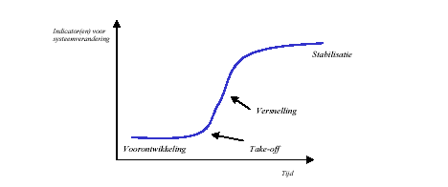
<vertaling>
Indications of system transitions
- pre development
- take off
- acceleration
- stabilization
</vertaling>

Figure 1: Four phases in a transition best visualized by means of an S curve.

Three drastic transitions
When we go back into the past three transitions took place with far-reaching effects.

- The first industrial revolution
The first industrial revolution lasted from around 1780 tot 1850. It was characterized by a transition from small scale handwork to mechanized production in factories. The great catalyst in the process was the steam engine which also caused a revolution in transport as it was used in railways and shipping. The first industrial revolution was centered around the cotton industry. Because steam engines were made of iron and ran on coal, both coal mining and iron industry also came to bloom.
This revolution ended in 1845 when Friedrich Engels, son of a German textile baron, described the living conditions of the English working class in “The condition of the working class in England“. The result of this revolution: an immense gap between rich and poor.

- The second industrial revolution
The second industrial revolution started around 1870 and ended around 1930. It was characterized by ongoing mechanization because of the introduction of the assembly line, the replacement of iron by steel and the development of the chemical industry. Furthermore coal and water were replaced by oil and electricity and the internal combustion engine was developed. Whereas the first industrial revolution was started through (chance) inventions by amateurs, companies invested a lot of money in professional research during the second revolution, looking for new products and production methods. In search of finances small companies merged into large scale enterprises which were headed by professional managers and shares were put on the market. These developments caused the transition from the traditional family business to Limited Liability companies and multinationals.
After the roaring twenties the revolution ended with the stock exchange crash of 1929. The consequences were disastrous culminating in the Second World War.

- The third industrial revolution
The third industrial revolution started around 1940 and is nearing its end. The United States and Japan played a leading role in the development of computers. During the Second World War great efforts were made to apply computer technology to military purposes. After the war the American space program increased the number of applications. Japan specialized in the use of computers for industrial purposes such as the robot. By now the computer and communication technology take up an irreplaceable role in all parts of the world.
The acceleration phase of the third industrial revolution started around 1980 with the introduction of the micro processor. The third industrial revolution has clearly reached the saturation and degeneration phase.

Dow Jones Industrial Average
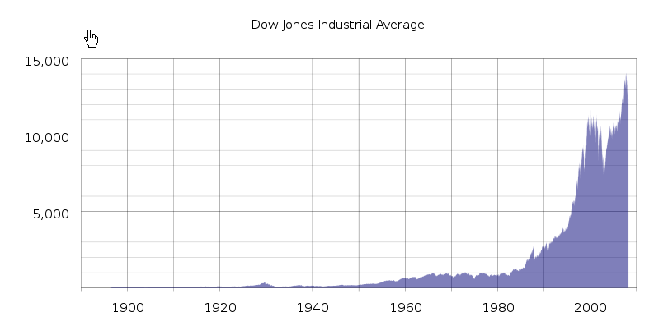
Figure 2: Exchange rates of Dow Jones during the latest two industrial revolutions. During the last few years the rate increases have accelerated enormously.

Stock index graphs are fata morganas.

What does a stock exchange index like DJIA, S&P 500 or AEX really mean?

The Dow Jones Industrial Average (DJIA) index is the oldest shares index in the United States. A select group of journalists of The Wall Street Journal decide which companies are included in the most influential stock exchange index in the world.
Unlike most other indices the Dow is a price average index. This means that shares with a high price have a great influence on the movements of the index.

The S&P index is a market value index. This index, compiled by credit evaluator Standard & Poor’s, includes the 500 largest US companies, based on their market capitalization
The Amsterdam Exchange Index (AEX) is the most important stock exchange index in the Netherlands. It shows the development of share prices of the top 25 funds of the Amsterdam Stock Exchange, based on trading. The AEX is the average price of the shares of those funds.

In many graphs the y-axis is a fixed unit, such as kg, meter, liter or euro. In the graphs showing the stock exchange values, this also seems to be the case because the unit shows a number of points. However, this is far from true! An index point is not a fixed unit in time and does not have any historical significance.
An index is calculated on the basis of a set of shares. Every index has its own formula and the formula gives the number of points of the index. Unfortunately many people attach a lot of value to these graphs which are, however, very deceptive.

- An index is calculated on the basis of a set of shares. Every index has its own formula and the formula results in the number of points of the index. However, this set of shares changes regularly. It is therefore very strange that different sets of shares are represented by the same unit.
After a period of 25 years the value of the original set of apples is compared to the value of a set of pears. At the moment only 6 of the original 30 companies that made up the set of shares of the Dow Jones at the start of the acceleration of the last revolution (in 1979) are still present.
Even more disturbing is the fact that with every change in the set of shares used to calculate the number of points, the formula also changes. This is done because the index which is the result of two different sets of shares at the moment the set is changed, must be the same for both sets at that point in time. The index graphs must be continuous lines. For example, the Dow Jones is calculated by adding the shares and dividing the result by a number. Because of changes in the set of shares and the splitting of shares the divider changes continuously. At the moment the divider is 0.132319125 but in 1985 this number was higher than 1. An index point in two periods of time is therefore calculated in different ways:
Dow1985 = (x1 + x2 + ........+x30) / 1
Dow2009 = (x1 + x2 + ........ + x30) / 0,132319125
In the nineties of the last century many shares were split. To make sure the result of the calculation remained the same both the number of shares and the divider changed (which I think is wrong). An increase in share value of 1 dollar of the set of shares in 2009 results is 7.5 times more points than in 1985. The fact that in the 1990-ies many shares were split is probably the cause of the exponential growth of the Dow Jones index. At the moment the Dow is at 9665 points. If we used the 1985 formula it would be at 1279 points.
- The most remarkable characteristic is of course the constantly changing set of shares. Generally speaking, the companies that are removed from the set are in a stabilization or degeneration phase. Companies in a take off phase or acceleration phase are added to the set. This greatly increases the chance that the index will rise rather than go down. This is obvious, especially when this is done during the acceleration phase of a transition.
This is actually a kind of pyramid scheme. All goes well as long as companies are added that are in their take off phase or acceleration phase. At the end of a transition there will be fewer companies in those phases.

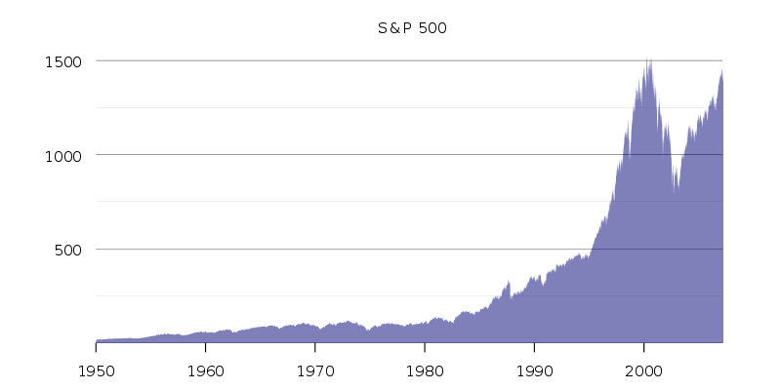
<<Fig 3: 3rd industrial revolution and the S&P 500 >>

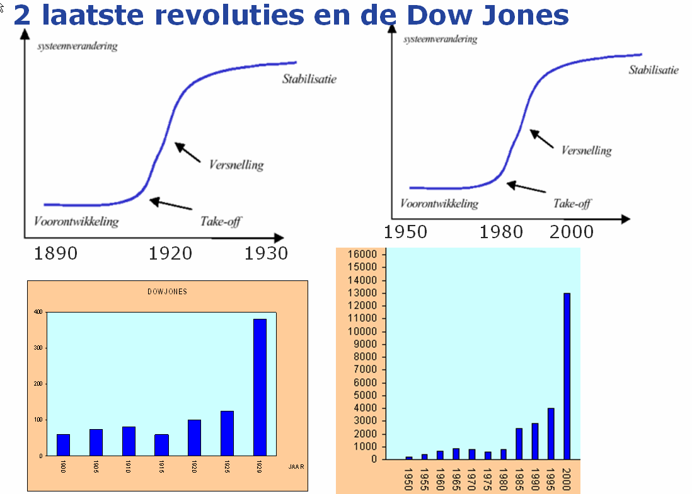

<vertaling>
Indications of system transitions
- pre development
- take off
- acceleration
- stabilization
</vertaling>

<<The two most recent revolutions and the Dow Jones index>>

Will the share indexes go down any further?

Calculating share indexes as described above and showing indexes in historical graphs is a useful way to show which the industrial revolution is in.

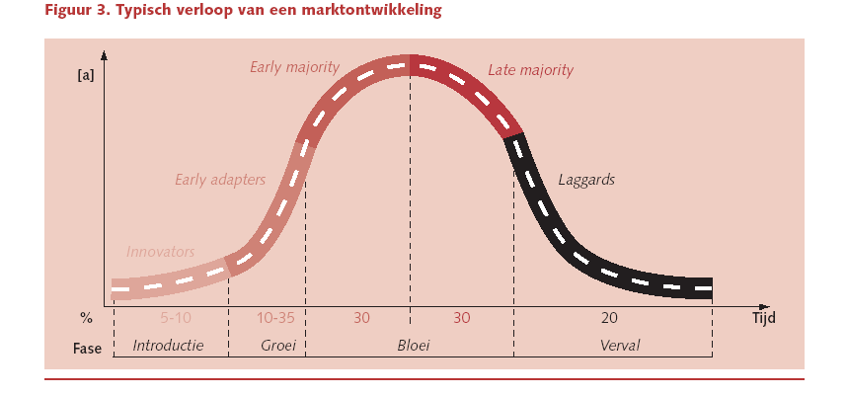
Introduction
Growth
Flourishing
Decline

<< Fig 4: Typical course of market development >>

The third industrial revolution is clearly in the saturation and degeneration phase. This phase can be recognized by the saturation of the market and the increasing competition. Only the strongest companies can withstand the competition or take over their competitors (like for example the take-overs by Oracle and Microsoft in the past few years). The information technology world has not seen any significant technical changes recently, despite what the American marketing machine wants us to believe.
During the pre development phase and the take off phase of a transition many new companies spring into existence. This is a diverging process. Especially financial institutions play an important role here. These phases require a lot of money. The graphs showing the wages paid in the financial sector therefore shows the same S curve as both revolutions.

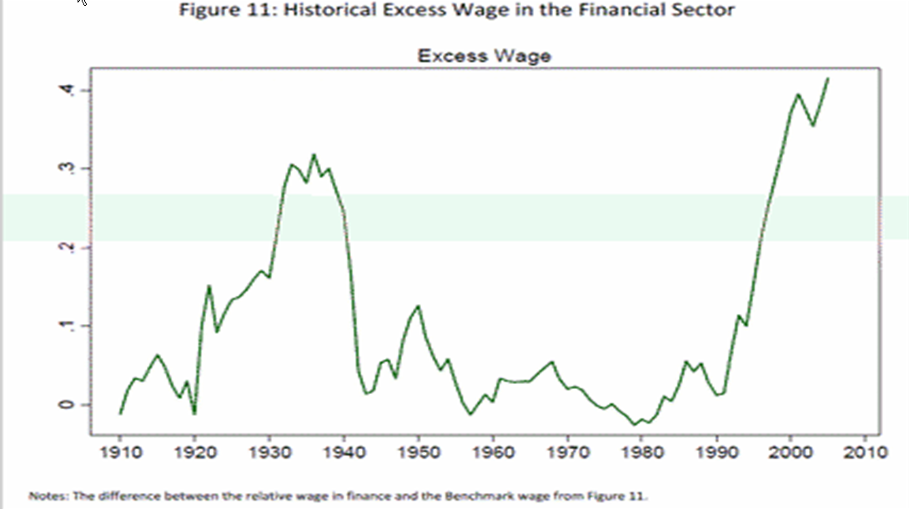
<< Fig Historical excess wage in the financial sector >>

Investors get euphoric when hearing about mergers and take overs. Actually, these mergers and take overs are indications of the converging processes at the end of a transition. When looked at objectively each merger or take over is a loss of economic activity. This becomes painfully clear when we have a look at the unemployment rates of some countries.

New industrial revolutions come about because of new ideas, inventions and discoveries, so new knowledge and insight. Here too we have reached a point of saturation. There will be fewer companies in the take off or acceleration phase to replace the companies in the index shares sets that have reached the stabilization or degeneration phase.

In the graph below we see the share price/income ratio over the past two industrial revolutions. At the end of the 2nd industrial revolution in 1932 this index reached 5. At the moment we are at 15. The index prices can still go down by a factor 3.

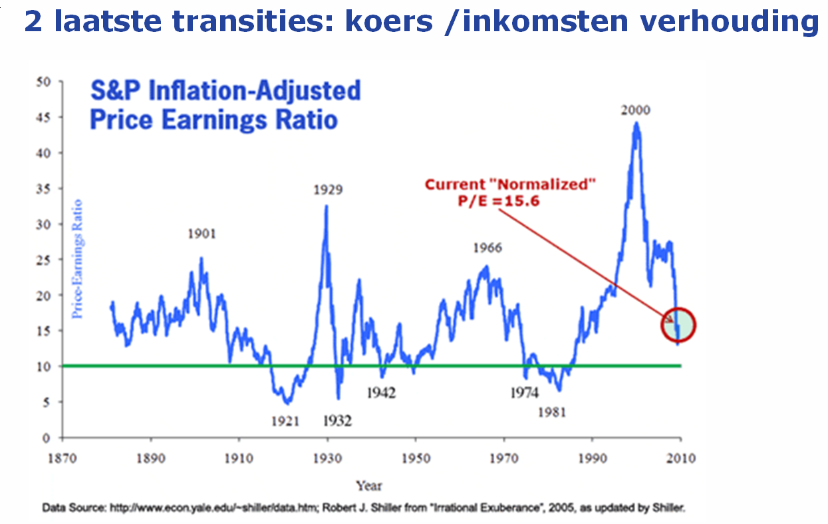
<< Fig 2 industrial revolutions: share price / income ratio >>

Will history repeat itself?
Humanity is being confronted with the same problems as those at the end of the second industrial revolution such as decreasing stock exchange rates, highly increasing unemployment, towering debts of companies and governments and bad financial positions of banks.

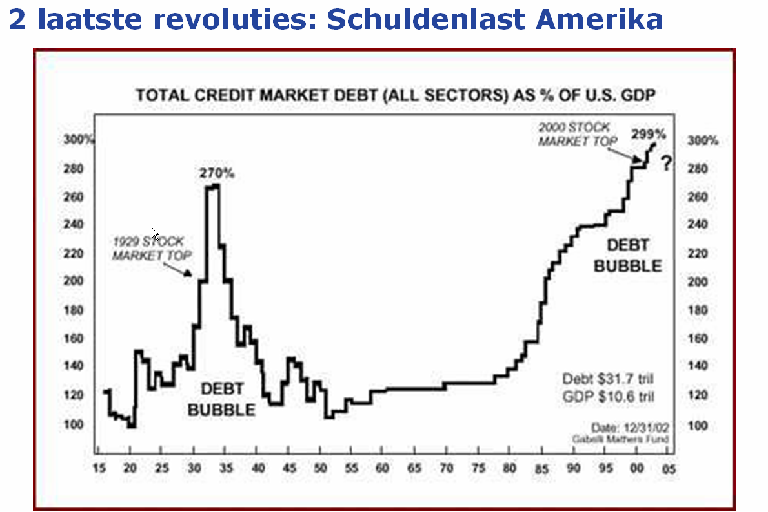

<< Fig Two most recent revolutions: US market debt >>

Transitions are initiated by inventions and discoveries, the knowledge of mankind. New knowledge influences the other four components in a society. At the moment there are few new inventions or discoveries. So the chance of a new industrial revolution is not very high.
History has shown that five pillars are indispensable for a stable society.

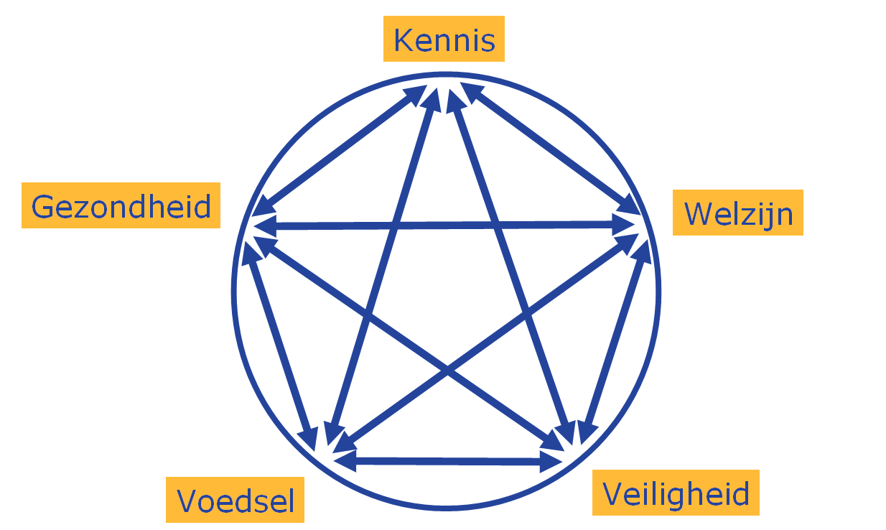

Knowledge
Prosperity
Security
Food
Health

<< Fig The five pillars for a stable society >>

At the end of every transition the pillar Prosperity is threatened. We have seen this effect after every industrial revolution.
The pillar Prosperity of a society is about to fall again. History has shown that the fall of the pillar Prosperity always results in a revolution. Because of the high level of unemployment after the second industrial revolution many societies initiated a new transition, the creation of a war economy. This type of economy flourished especially in the period 1940 – 1945.

Now, societies will have to make a choice for a new transition to be started.

Wim Grommen

Source:

The article “A new stock market crash, a pattern?”, in dutch "Nieuwe beurskrach, een wetmatigheid?” was published in February 2010 in a magazine “Tijdschrift voor economisch onderwijs” (magazine for economical education), a monthly publication of the VECON, A union of teachers in economic and social subjects in the Netherlands.

