Greetings.

Today was one of those-break-out-the-pacifier and tell me a bedtime story days. They do come, and ironically, particularly during the final part of a correction within a bull market.   These days are never very dainty or enjoyable. Its very nature serves to discourage, scare and even implant suicidal thoughts in the most cheerful of investors. More practically it can make the fearful panic and sell, just when he should be buying. I am certain all of us have probably done this in our market history.

That is why I cited that the single most important feature of a valuable adviser, similar to the military figures we see in the movies, is to encourage the troops when the going gets bad. After Joshua had assumed command from Moses of the 12 tribes of Israel, time and again his princial message was to encourage his troops, just as they were about to cross into the new land.  I am neither Joshua nor General Patton, but I think I can try to encourage you here because I as well as you have seen this drill before.

And these are the kind of lessons that help us navigate through the hard days and give us confidence that we are on the correct path. I know that after 11 years in the gold complex, I remain resolute about what will eventually transpire.

Keep in mind that, as horrible as the selloff in the metals was back in late 2008, gold is still well up over 100% from then, and silver almost 4 times. On the bottom the HUI touched 150, but within 3 months it had doubled (see below.) And the worst day in the Dow bull market came in November 1987 when the market plunged 505 points on that Monday. But imagine that instead of selling as so many did, one had contrarily bought, he would have made almost 1500% in the Dow alone. It looks easy and natural in hindsight, but it takes perspective, courage and discipline at the time.

 HUI January 2008-November 2009

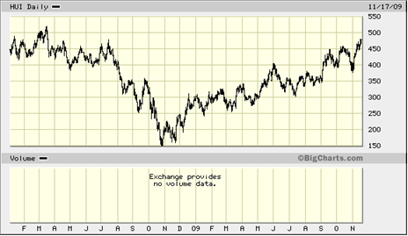

Also, some other things to keep in perspective now is that this week not only closes out an option expiration (might be rough tomorrow, also) but right before a 3 day holiday week. But barring something totally unannounced we should be ready to bottom. If you consider yourself a contrarian, then perhaps this is the time to consider bidding on the shares you have been holding back on, not to sell. I remember that at the darkest days of the gold share decline, it looked like the shares were a gift, but to buy them even at those levels took courage.

From what I have seen and still firmly believe, we are still in the early stages of a parabolic move that will conclude in the most spectacular blow off in history. The gold market is still tracing out the high tech pattern of the early 1990s when the public was still not really in the stock market. But at a point, after a sharp correction in 1994, they slowly came in and eventually in a fit of greed and confidence threw everything into the market. You can tell that I believe in checking out long-term charts.

NASDAQ JANUARY 1994-NOVEMBER 1995

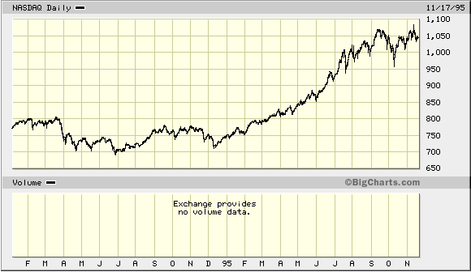

As Jim Sinclair constantly reminds us: nothing has changed over the past 11 years. In fact, things have only worsened. So why would gold, still devoid of any speculation or public participation now decide to break down. Besides the sentiment is nowhere near what is was at the top in February 2008. As back in the black days in November 2008, this will be just a pit stop.